===========================================================
SQL BOOK 2
Exercise-2
===========================================================
From this exercise onwards all solutions of SQL are given after the last chapter.
Create the following tables with necessary constraints.
WORKER (WORKER_ID, NAME, WAGE_PER_HOUR, SPECIALISED_IN, MANAGER_ID)
JOB (JOB_ID, TYPE_OF_JOB, STATUS)
JOB_ASSIGNED (WORKER_ID, JOB_ID, STARTING_DATE, NUMBER_OF_DAYS)

- SQL command to create the WORKER table:

CREATE TABLE WORKER
(
WORKER_ID NUMBER(5) PRIMARY KEY,
NAME VARCHAR2(50) NOT NULL,
WAGE_PER_HOUR NUMBER(8,2) CHECK (WAGE_PER_HOUR > 0),
SPECIALISED_IN VARCHAR2(50),
MANAGER_ID NUMBER(5)
);

2. SQL command to create the JOB table:
CREATE TABLE JOB
(
JOB_ID NUMBER(5) PRIMARY KEY,
TYPE_OF_JOB VARCHAR2(50) NOT NULL,
STATUS VARCHAR2(20)
);

3. SQL command to create the JOB_ASSIGNED table:
CREATE TABLE JOB_ASSIGNED
(
WORKER_ID NUMBER(5) REFERENCES WORKER(WORKER_ID),
JOB_ID NUMBER(5) REFERENCES JOB(JOB_ID),
STARTING_DATE DATE,
NUMBER_OF_DAYS NUMBER(5) CHECK (NUMBER_OF_DAYS > 0)
);
4. Display the date on which each worker is going to end his presently assigned job.
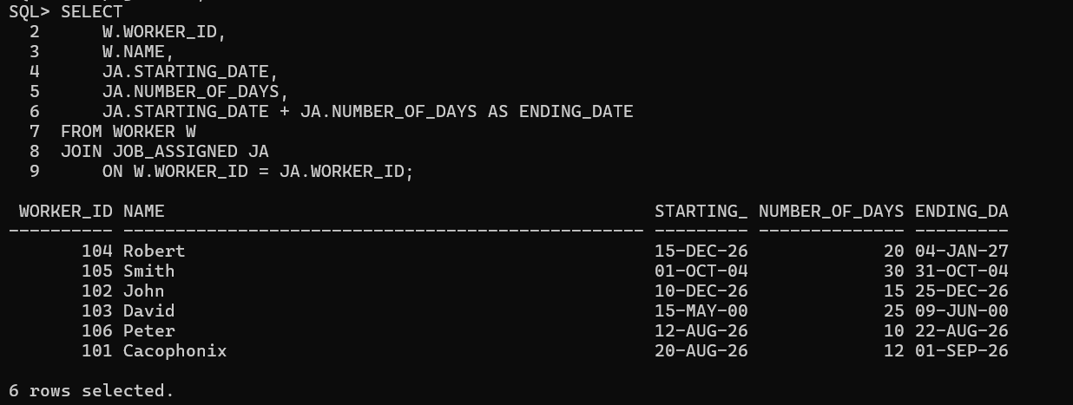
5. Display how many days remain for each worker to finish his job.
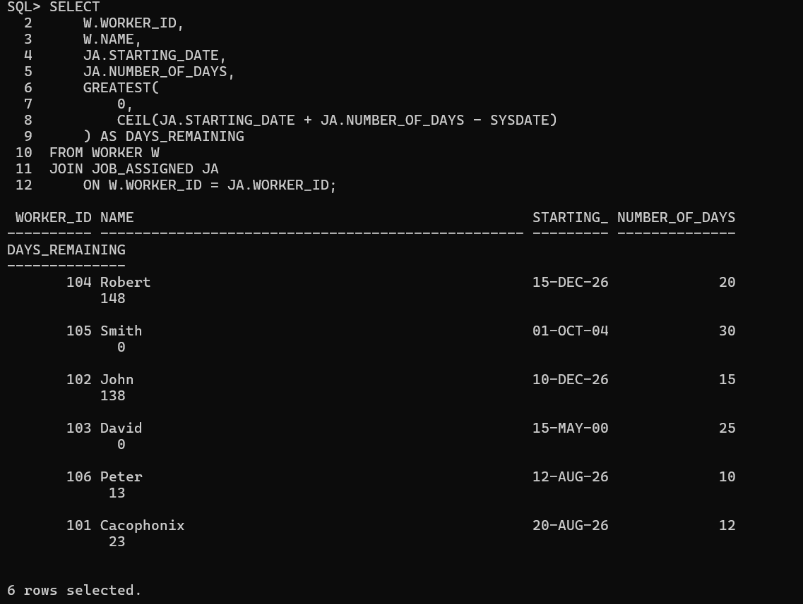
6. Display the STARTING_DATE in the following format - 'The fifth day of the month of October, 2004'.
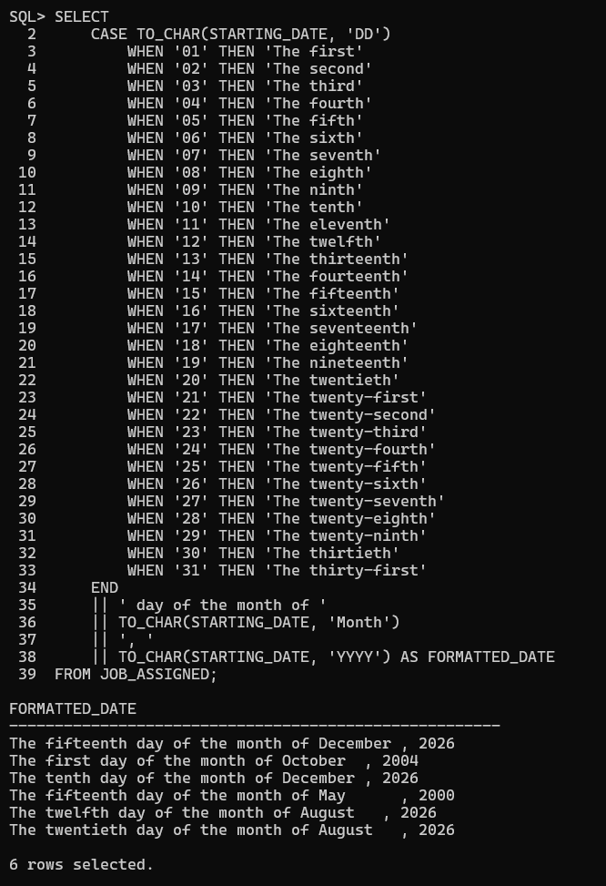
7. Give the necessary access rights to user SUPERVISOR so that he can only assign jobs to different workers.
8. Change the status to 'Complete' for all those jobs, which started in year 2000.
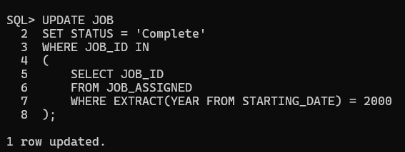
9. Display job details of all those jobs where at least 25 workers are working.
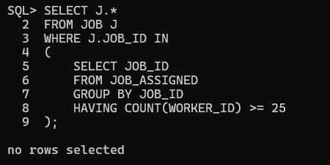
10. Display all those jobs that are already completed.
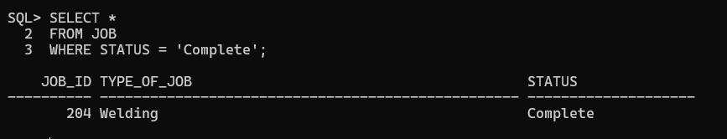
11. Find all the jobs, which will begin within the next two weeks.
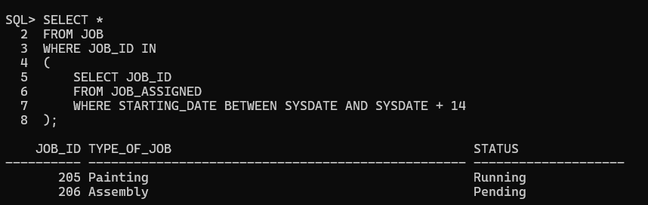
12. List all workers who have their wage per hour ten times greater than the wage of their managers.
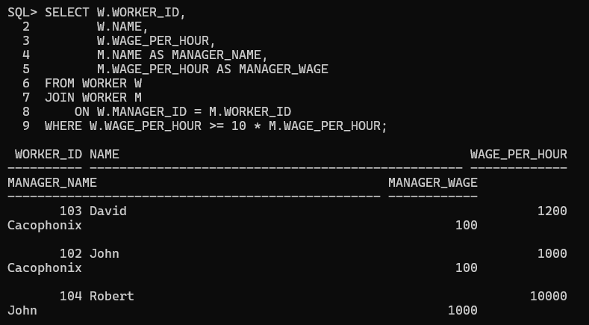
13. List the names of workers who have been assigned the job of molding.
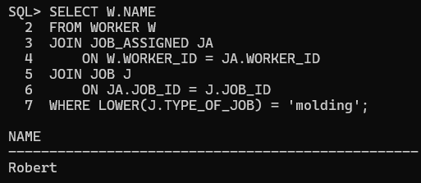
14. What is the total number of days allocated for packaging the goods for all the workers together. 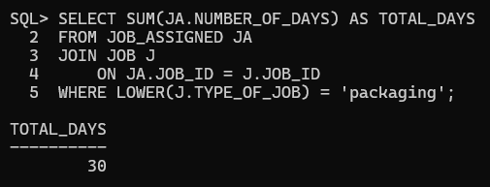
15. Which workers receive higher than average wage per hour.
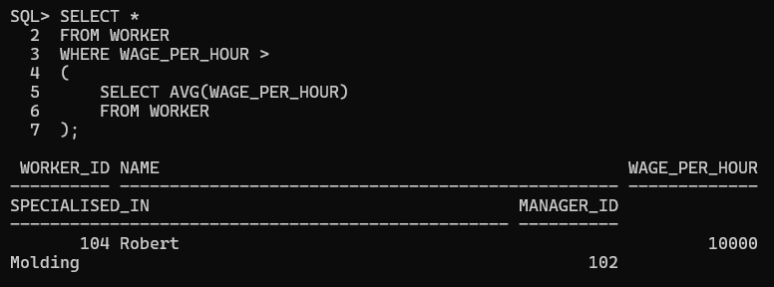
16. Display details of workers who are working on more than one job.
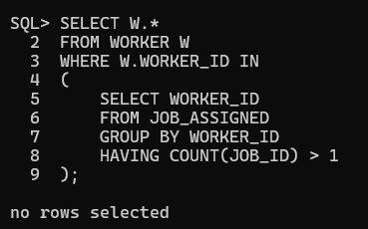
17. Which workers having specialization in polishing start their job in December?
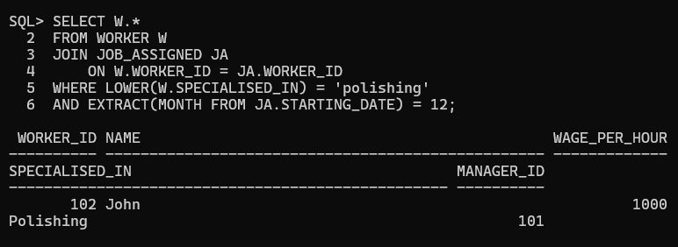
18. Display details of workers who are specialized in the same field as that of Mr. Cacophonix or have a wage per hour more than any of the workers.
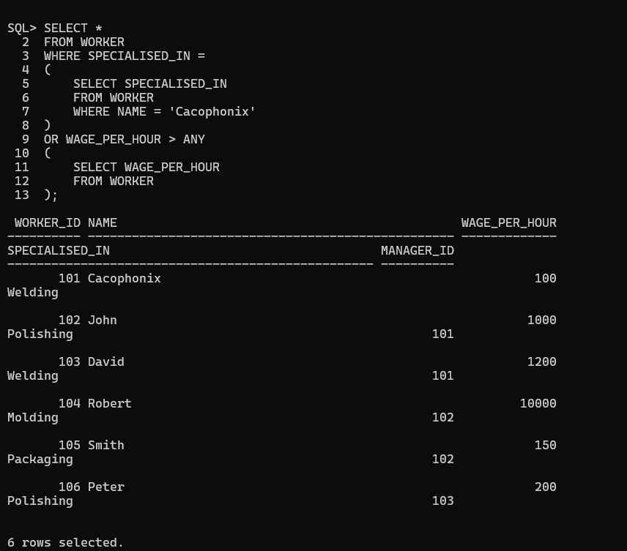
19. For each manager managing more than one worker, display the highest hourly wage paid to a worker, reporting to that manager.
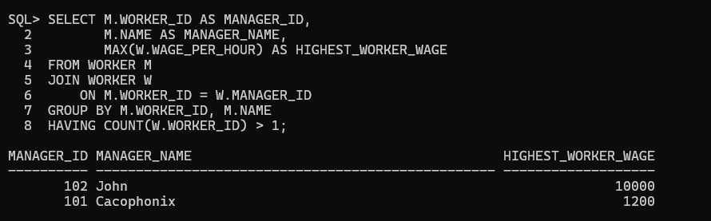
20. Display the specialization of the third lowest paid worker.
